Full stack web development project
FRESH MART PROJECT DOCUMENTS

Pictures of applications:

Main page:
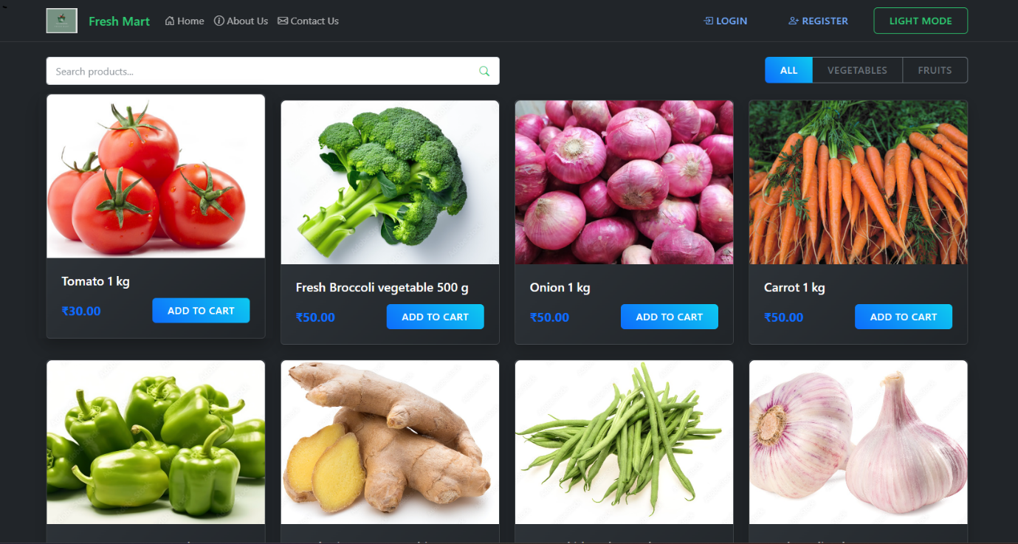
Home page includes all the products and categories, contact us , About us and Register and login feature.

Registration:

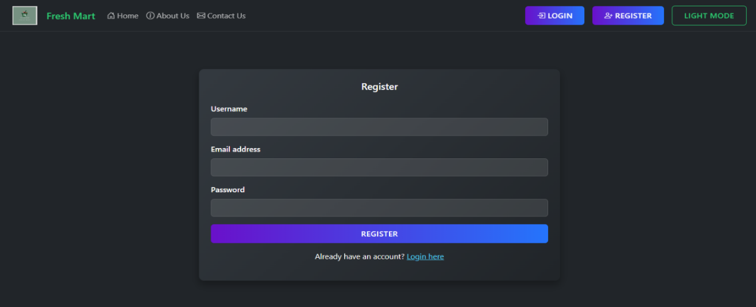

Log in page:
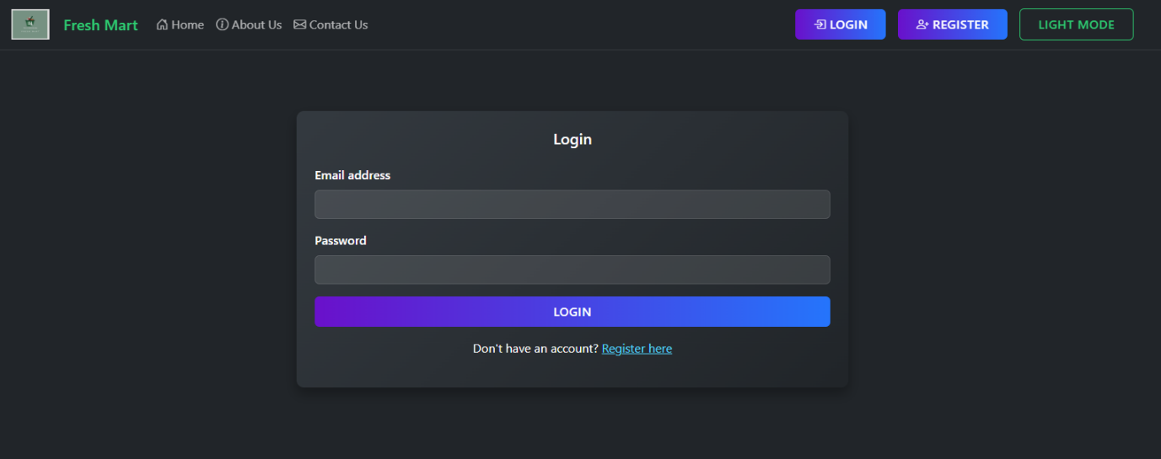
Cart page:
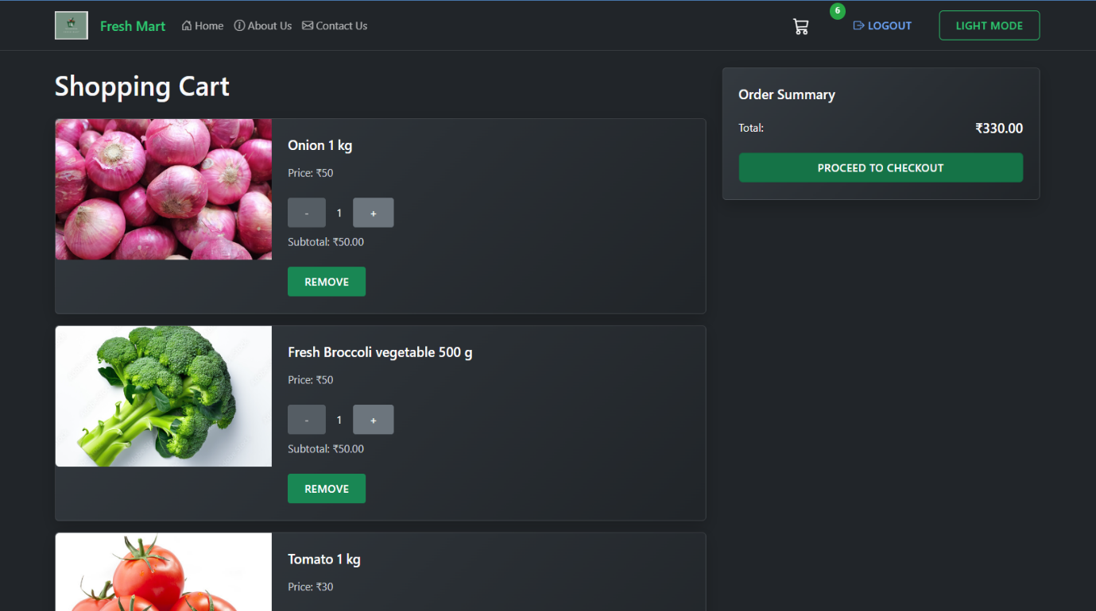
Cart pages include the overall products that a customer have been ordered.

Billing page:
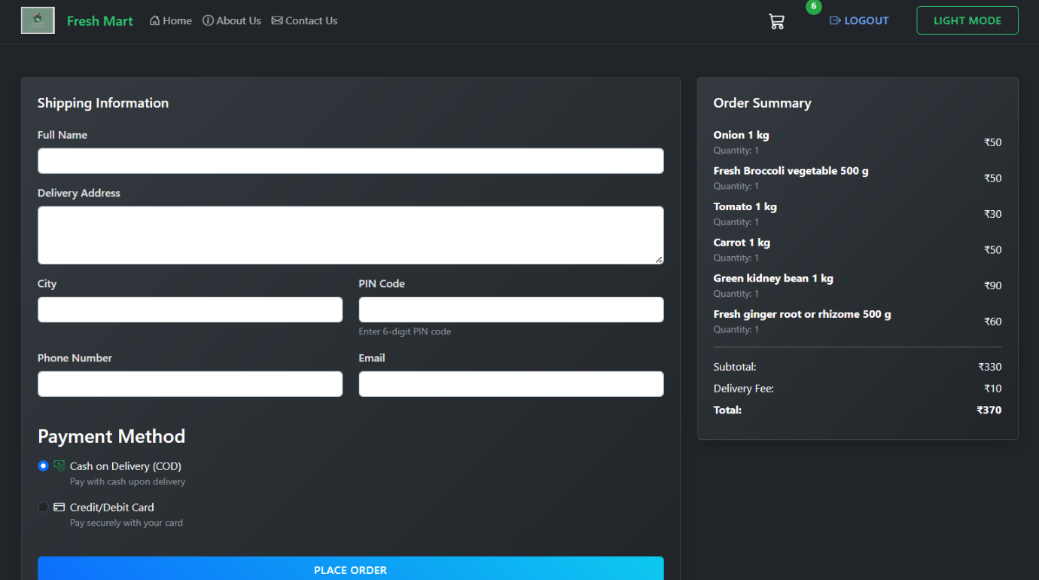
Conformation page:
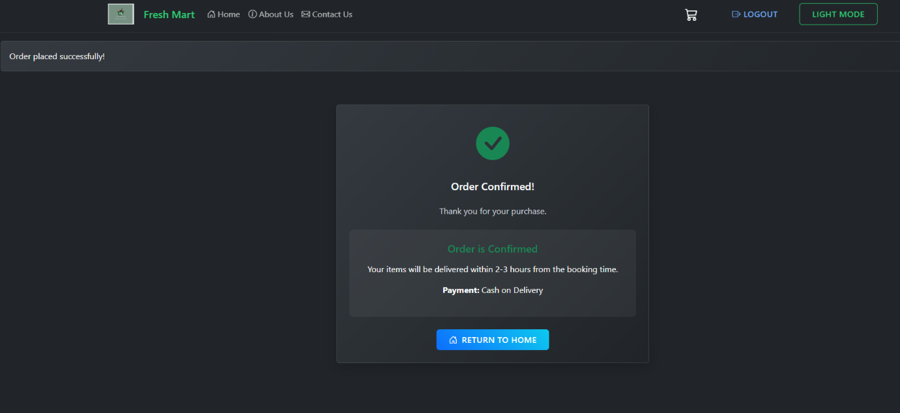
Admin dashboard:
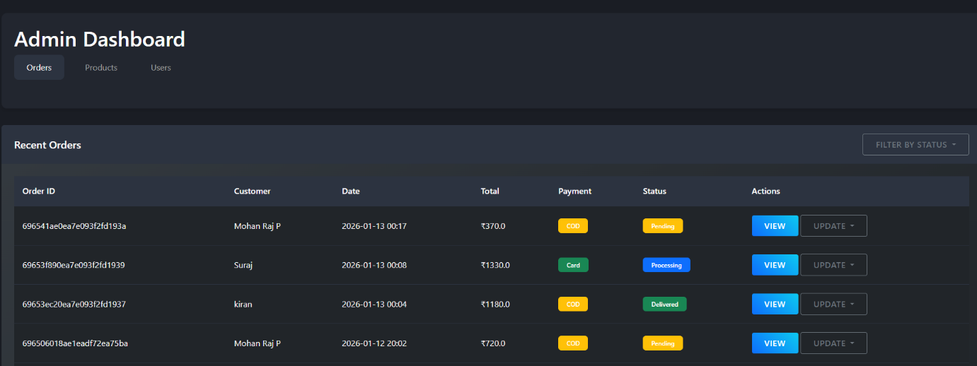
Admin Dashboard:
It contains three main features that are Orders, products , users
Orders: In this feature it contain all the customer information and admin will check the orders and based on that he will make the status Delivered, Processing , Pending and Canceled.

In case of adding new products

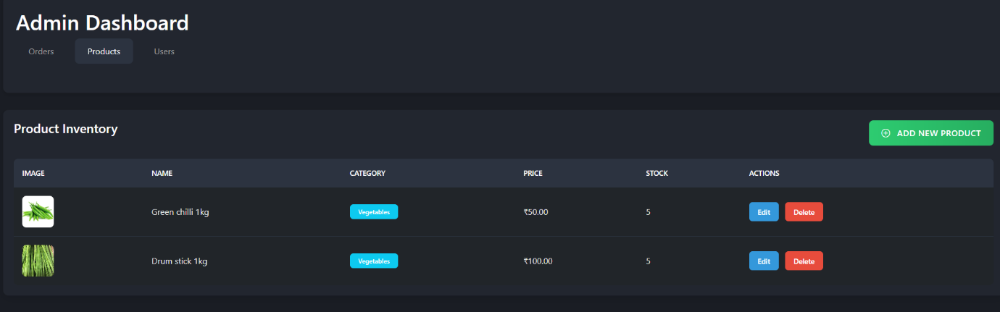
Products : In this feature the admin will have options to add new products and it will directly reach to the main page of the products.

Status of users:

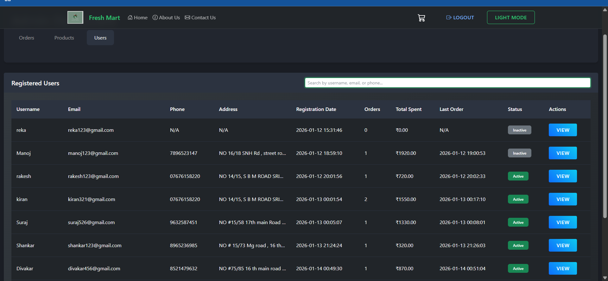

Users Tab : This is where the entire customer detalis will be present like time, number of customers, and other details one main thing is “once the product is delivered the status of the customer will become inactive”.

Customers profile:

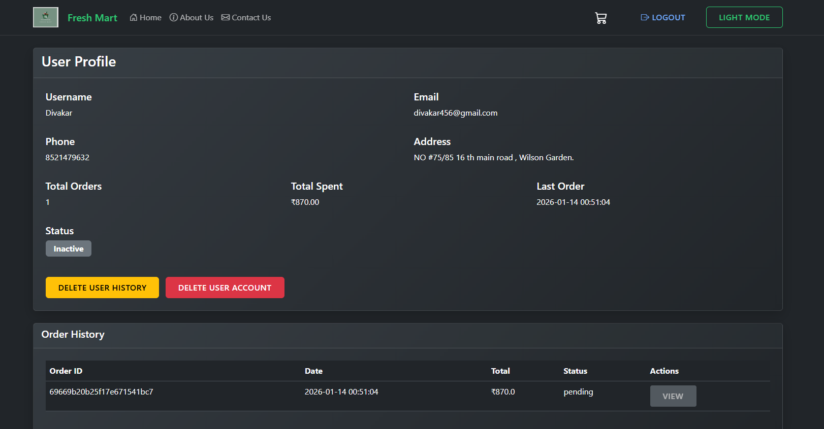

About us page:
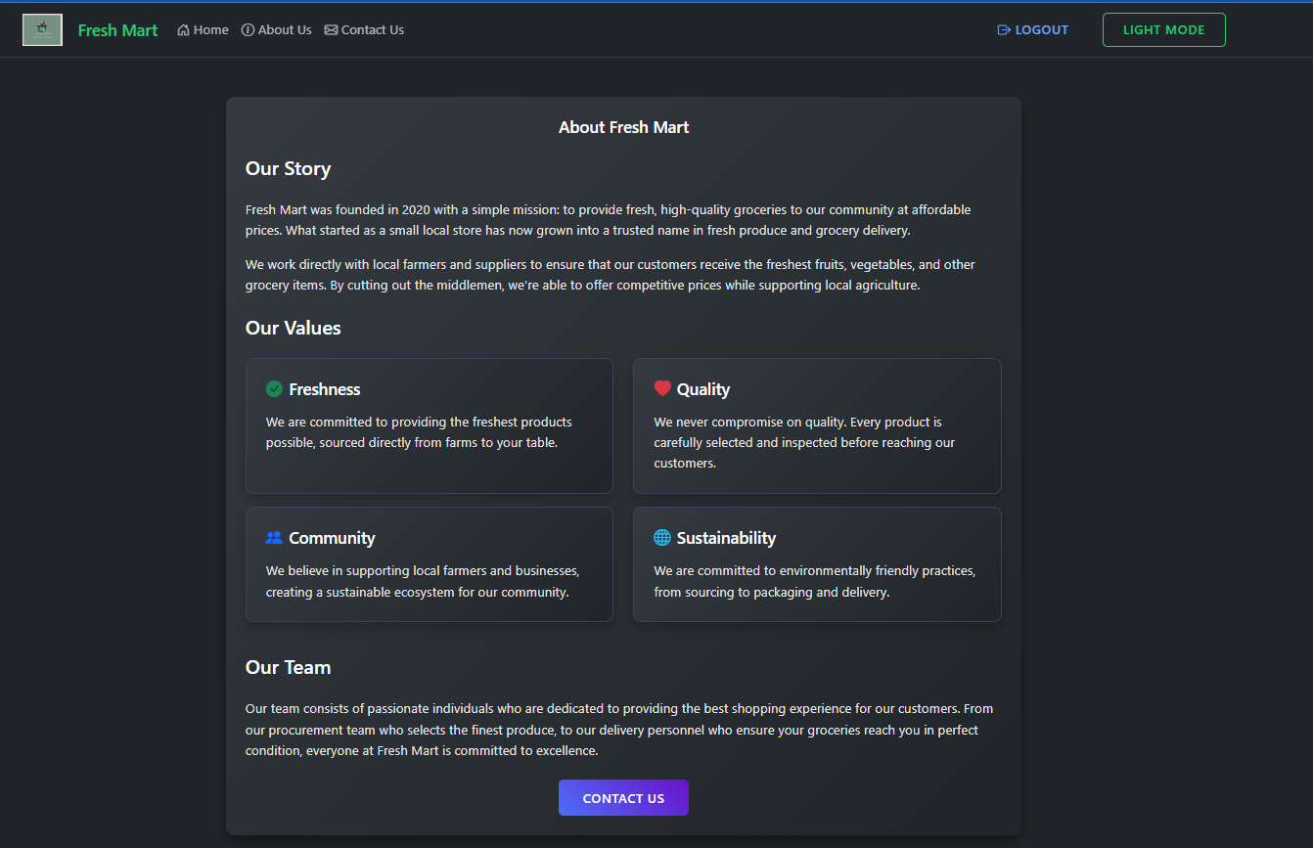

Database:

Of orders

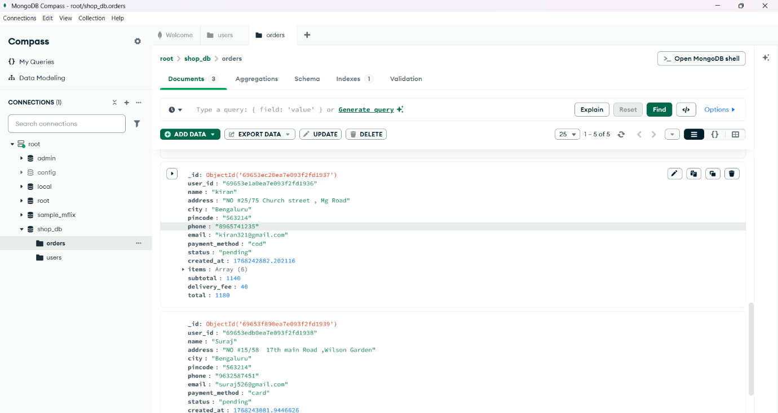

Of users:

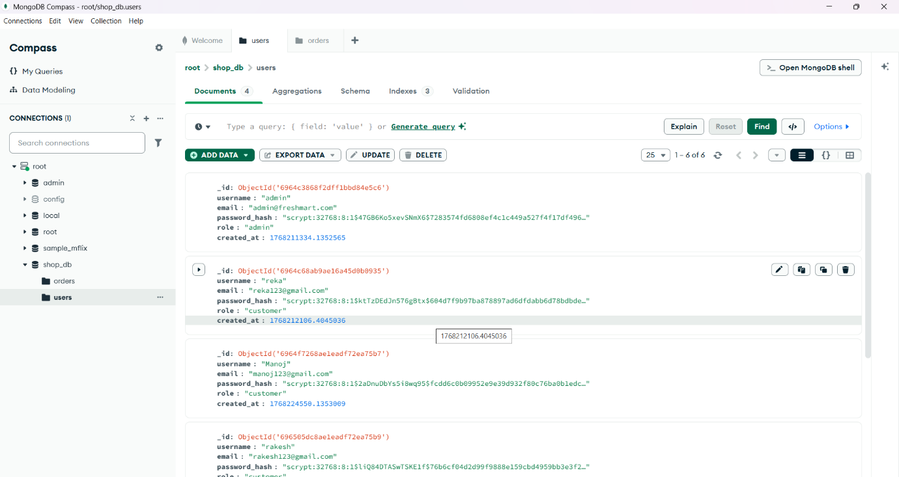
Tools and web frameworks used here:
FreshMarketPlace uses Flask (Python web framework), MongoDB Atlas (cloud database), Bootstrap 5 (responsive UI framework), JavaScript (client-side interactivity), HTML/CSS (markup/styling), PyMongo (MongoDB integration), Jinja2 (template engine), Werkzeug (security utilities), and Gunicorn (production server)

Jinja2 (Template Engine)
Jinja2 is a template engine for Python used with Flask to create dynamic HTML pages.
Gunicorn (Production Web Server)
Gunicorn (Green Unicorn) is a production-grade web server gateway interface (WSGI) server that runs Flask apps efficiently.

To run the application type this command:

"c:\Users\Admin\Desktop\github projects\FreshMarketPlace (2)\FreshMarketPlace\FreshMarketPlace" ; python app.py

